NPFC-2024-TWG CMSA08-WP12

**Growth and Mortality Estimation for Chub Mackerel based on Chinese data in the Convention Area of NPFC**

Qiuyun MA1, Zhiwei LIU1, Heng ZHANG2, Siquan TIAN1

1. College of Marine Sciences, Shanghai Ocean University, China

2. East China Sea Fisheries Research Institute, Chinese Academy of Fishery Science, China

**Summary**

As a highly migrate species, Chub mackerel is distributed in both the national waters of Japan and Russia and the high sea of Northwestern Pacific. The previous biology information used for stock assessment was almost based on results from Japanese fishery in its Exclusive Economic Zone. This research provides some analysis based the data from Chinese survey and fishery in the convention area. The parameters in the length-weight relationship of 2021-2023 were estimated to be 1.886~9.441×10-6for the condition factor *a*, and 3.03~3.32 for the growth parameter *b*, with significant temporal variations. Von Bertalanffy Growth parameters were estimated to be *K=*0.33~0.78, $L_{∞}$ =31~34 cm, and *t*0= -0.34 ~ -0.82. Both constant and age-specific natural mortality were calculated based on several empirical methods, while the *M* estimates ranged from 0.26 to 0.62 in different years, with geometrical mean to be 0.47. In conclusion, the results suggest obvious variations among different regions and years, indicating the non-stationarity of Chub mackerel’s life history traits. Based on this research, we strongly recommend the stock assessment for Chub mackerel using time-varying growth and mortality considering spatial heterogeneity.

**Introduction**

The growth and mortality parameters, as life history traits, are crucial for stock assessment to evaluate the population dynamics. At the stage of data preparation of Chub mackerel stock assessment, we need to estimate these input parameters based on substantial data. During the operating model conduction, this information was almost derived from Japan, focus on the stock in national waters rather than the convention area. This document provides information on the growth and mortality of Chub mackerel in the high sea based on data and studies from China, in order to improve our understanding of this migrate species and its stock assessment.

**Materials and Methods**

The 2021-2023 data comes from the fishery resource survey conducted by research vessel (RV) “Songhang” in the Northwest Pacific Ocean from June to August (Table 1). The separate between Chub mackerel and Blue mackerel was not made in 2021 and 2022, collectively referred as mackerel.

The fork length-weight relationship was estimated for all samples in these three years. And generalized mixed effects models was conducted to consider the temporal heterogeneity, with the random effect applied to the conditional factor *a*. The von Bertalanffy growth equation was estimated by the Electronic Length Frequency Analysis I (ELEFAN I) method in FiSATⅡ, while the aging process was not completed.

The natural mortality of CM was calculated based on sereval methods (Table 2). Parameters such as average water temperature ($\overline{T}$), maximum age (*t*max), and average fork length ($\overline{L}$) were derived from the survey data and other literatures. The temperature data were sourced from the National Oceanic and Atmospheric Administration (NOAA, [www.nnvl.noaa.gov](http://www.nnvl.noaa.gov/)).

**Table 1 Sampling size of mackerels for RV "Songhang" survey from 2021-2023**

|  |  |  |  |
| --- | --- | --- | --- |
| Year | survey stations | species | Sample size |
| 2021 | 42 | mackerel | 1261 |
| 2022 | 36 | mackerel | 397 |
| 2023 | 39 | Chub mackerel | 357 |

**Table 2 Methods for estimating natural mortality of Chub mackerel**

|  |  |  |  |
| --- | --- | --- | --- |
|  | Methods | Formula | Reference |
| M1 | Pauly | $$\ln{M}=-0.0152-0.279\ln{L_{∞}}+0.6543\ln{K}+0.463\ln{T}$$ | Pauly D, 1980 |
| M2 | Gislason | $$lnM=0.55-0.17\ln{L_{∞}}+\ln{K}$$ | Gislason H *et al*, 2010 |
| M3 | Charnov | $$M={K\left(L/L_{∞}\right)}^{-1.5}$$ | Charnov E L *et al*, 2013 |
| M4 | Bingyi zhan | $$M=-0.0021+\frac{2.5912}{t_{max}}$$ | Bingyi Zhan, 1986 |
| M5 | Jensen | $$M=1.5K$$ | Jensen A L, 1996 |
| M6 | Alverson | $$M=\frac{3K}{e^{0.38t_{max}K}-1}$$ | Alverson D L *et al*, 1975 |
| M7 | Hoening | $$lnM=1.44-0.9821lnt_{max}$$ | Hoening J M, 1983 |
| M8 | Gislason1 | $$M=1.73L^{-1.61}L_{∞}^{1.44}K$$ | Gislason et al., 2010 |

**Results**

The length distribution and length-weight curve were both plotted for Chub mackerel from 2021 to 2023 (Figures 2 and 3). The dominant length increased, from 120-140mm in 2021, to 160-180mm in 2022, and 200-240mm in 2023. The parameters in the length-weight relationships were estimated to be 1.886~9.441×10-6for the condition factor *a*, and 3.03~3.32 for the growth parameter *b*. Considering the temporal variations, results of mixed effects model suggested that the growth curves of CM collected in 2022 and 2023 were almost similar, gaining larger weight at the same length compared with the samples in 2021 (Figure 3).

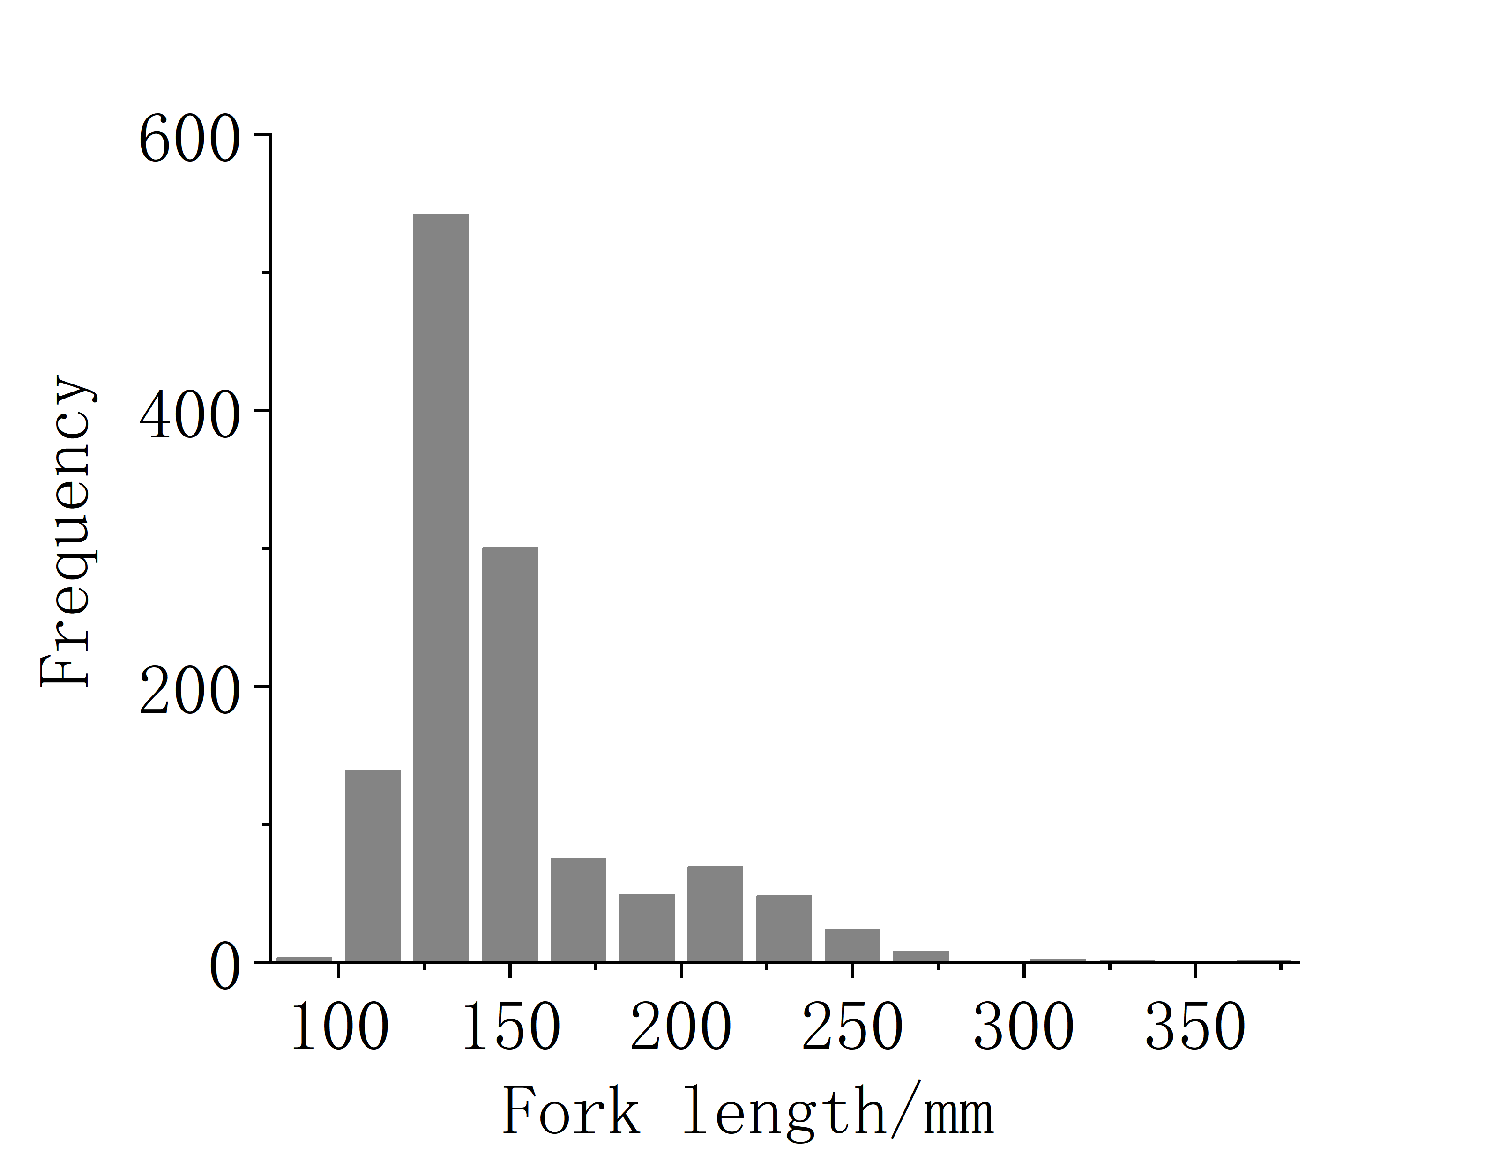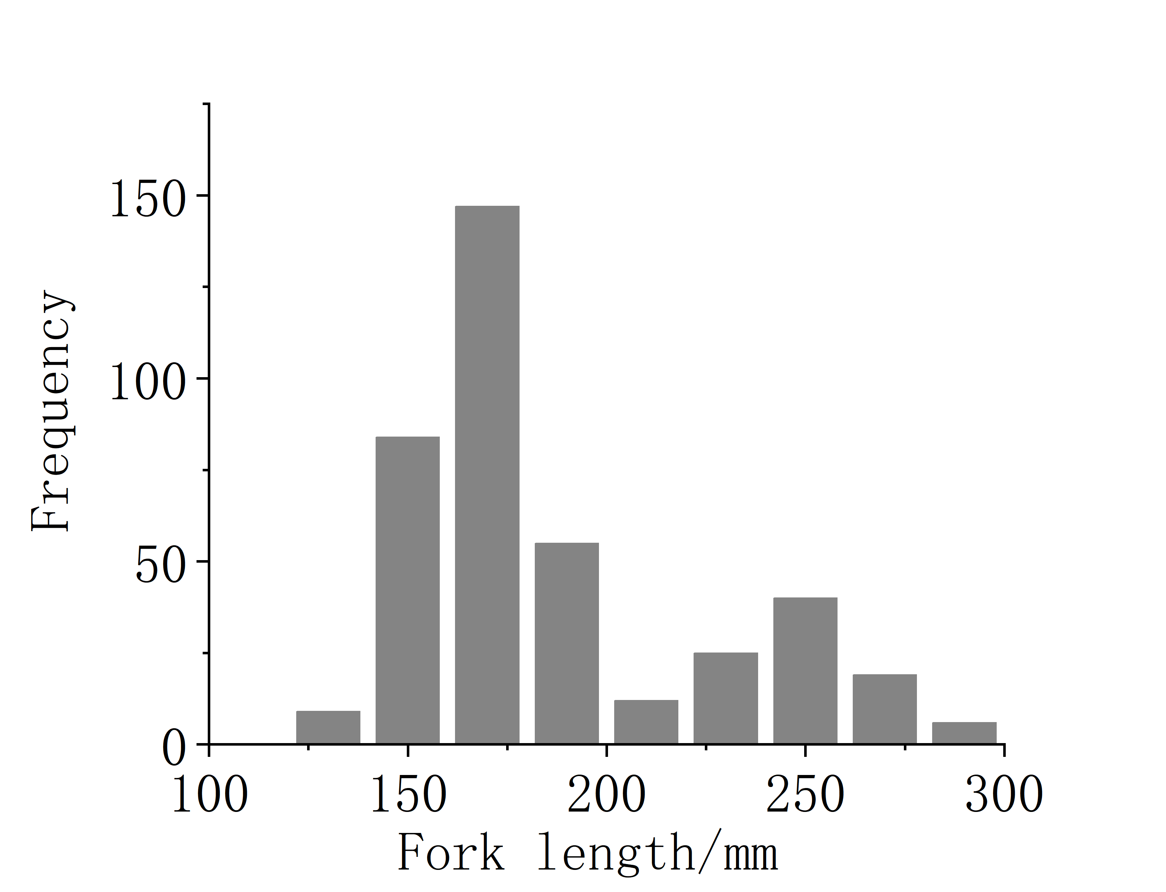 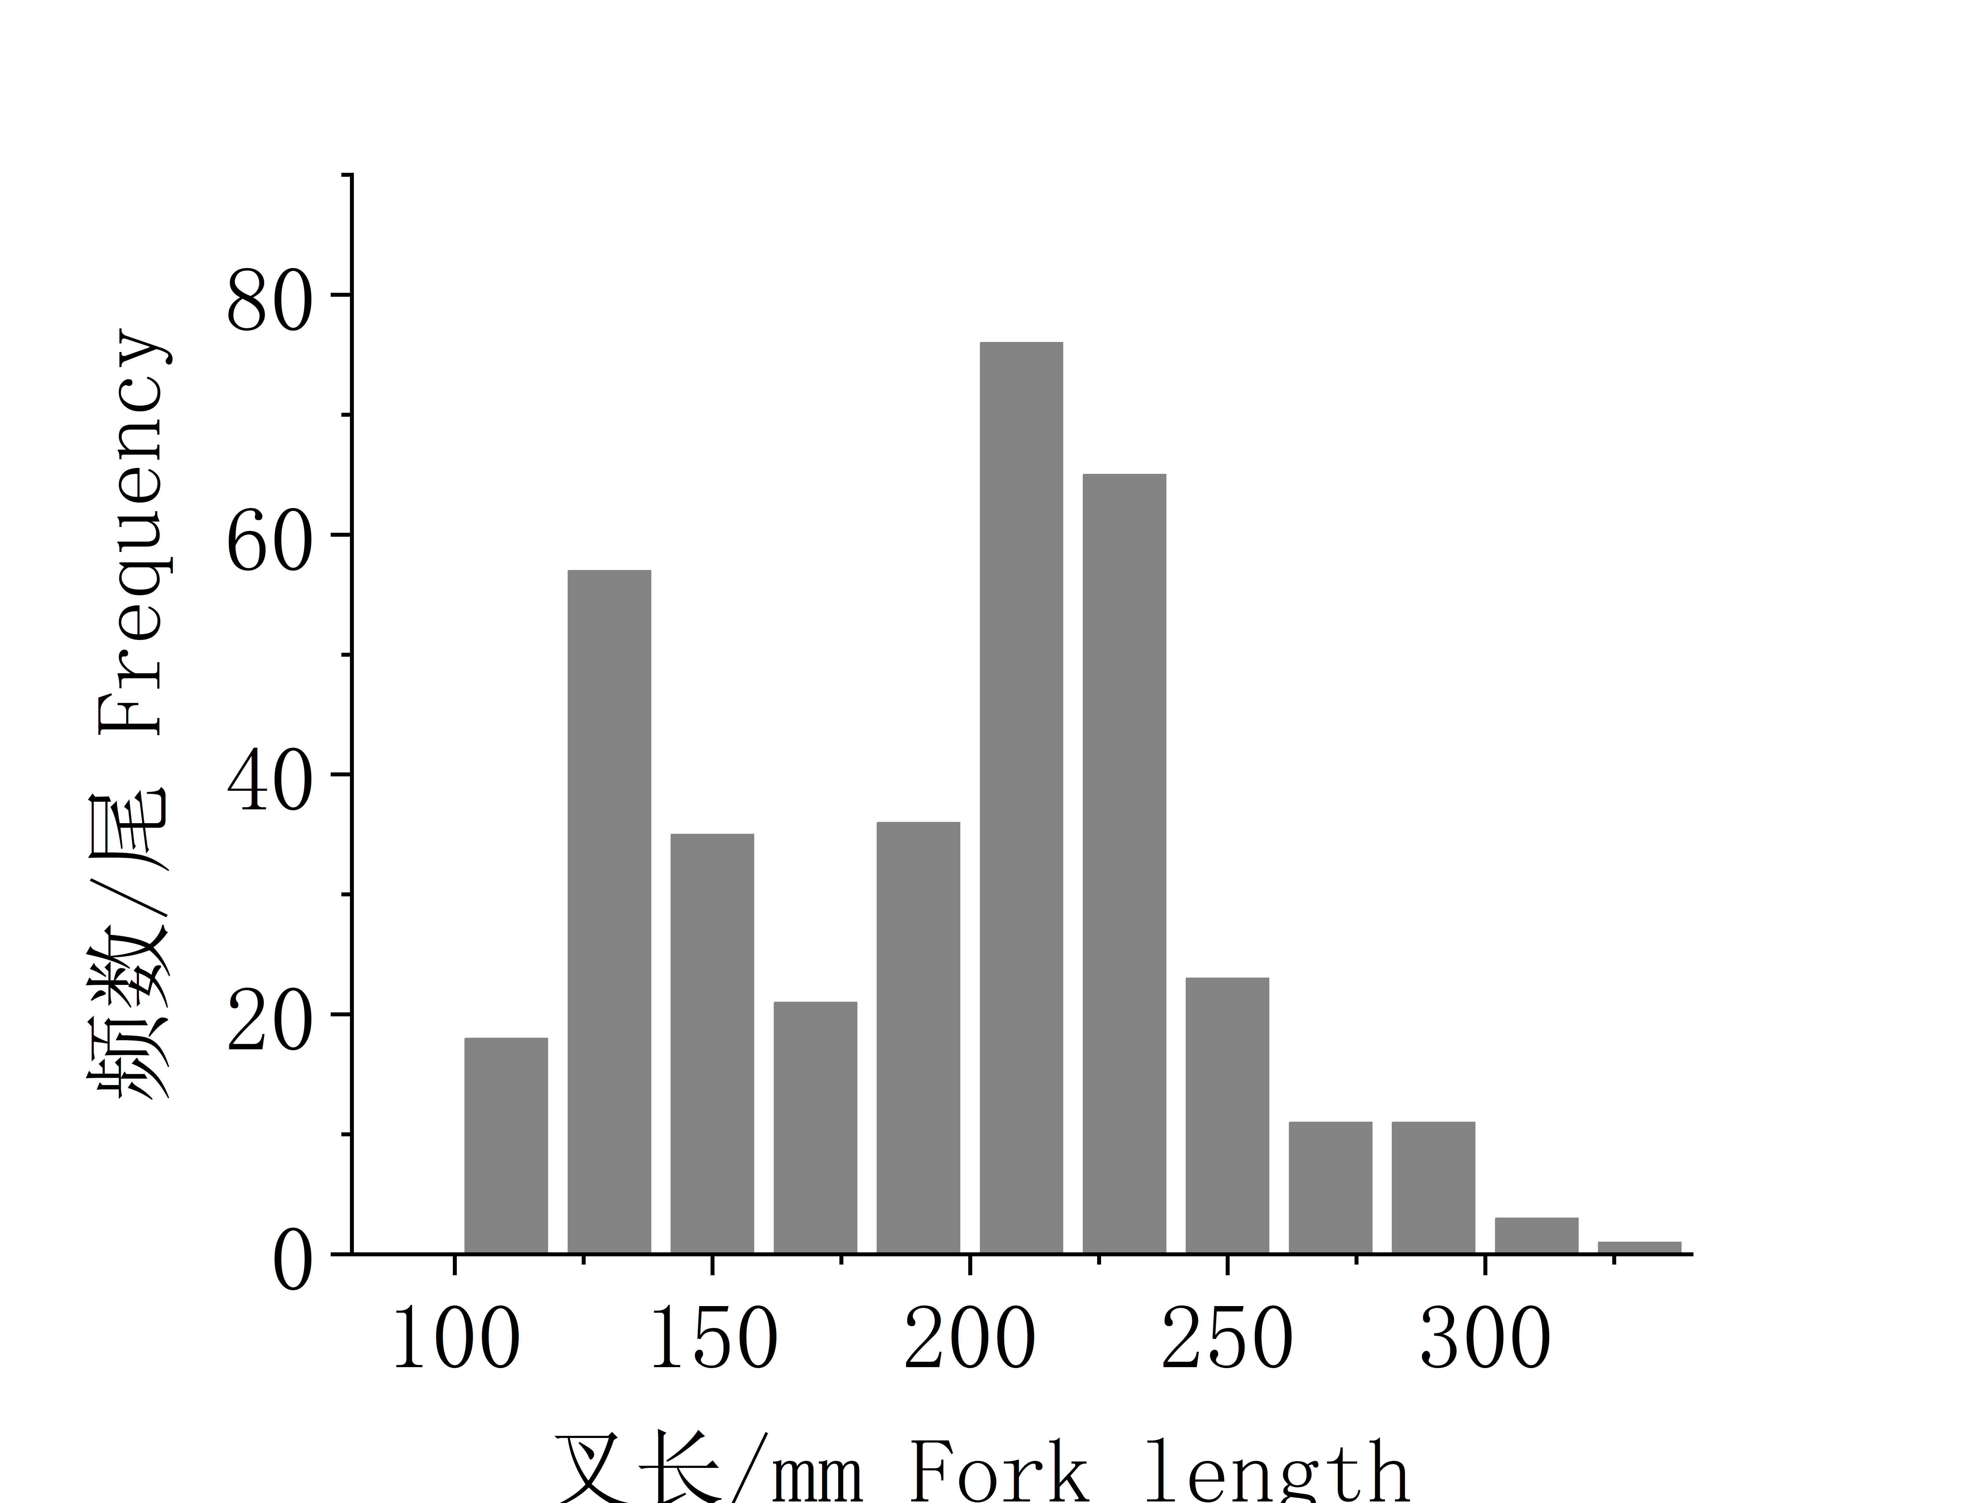

**Figure 2 The fork length distribution of Chub mackerel collected from RV Songhang surveys from 2021 to 2023 (left, middle, right, respectively)**

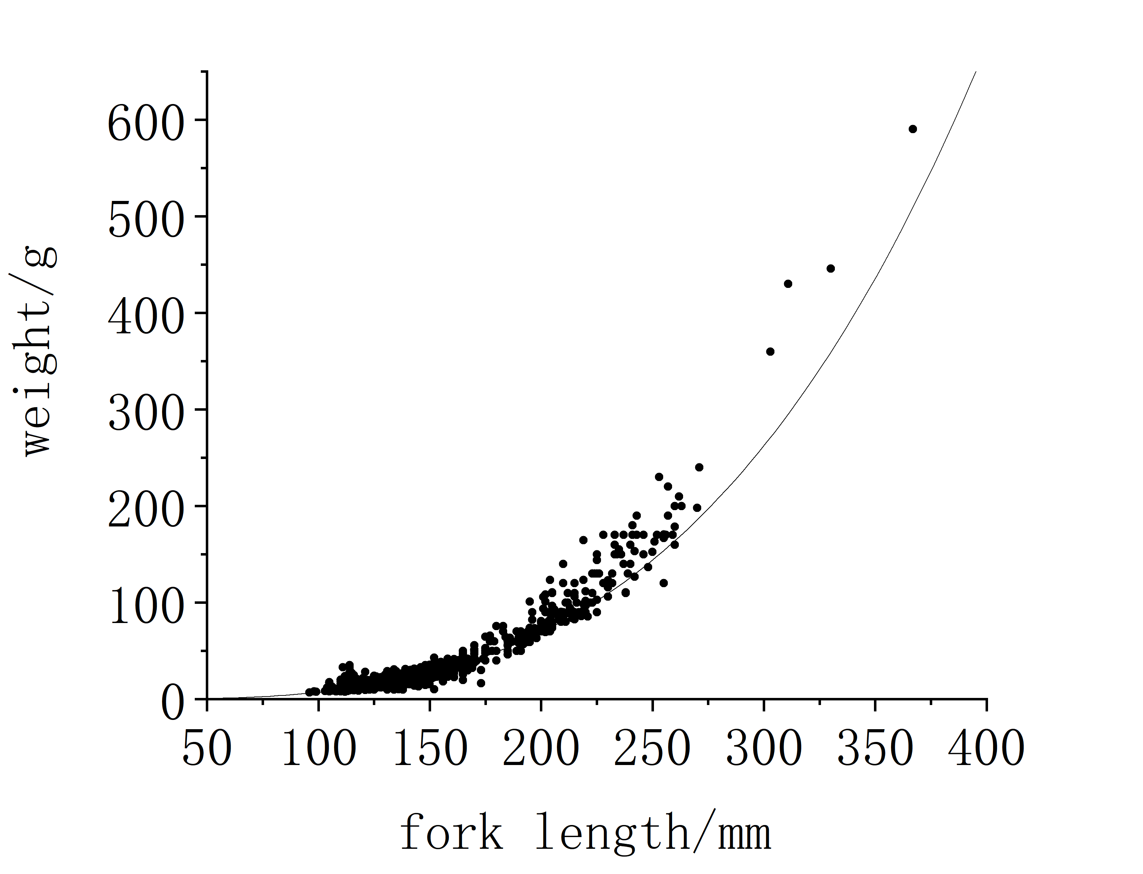 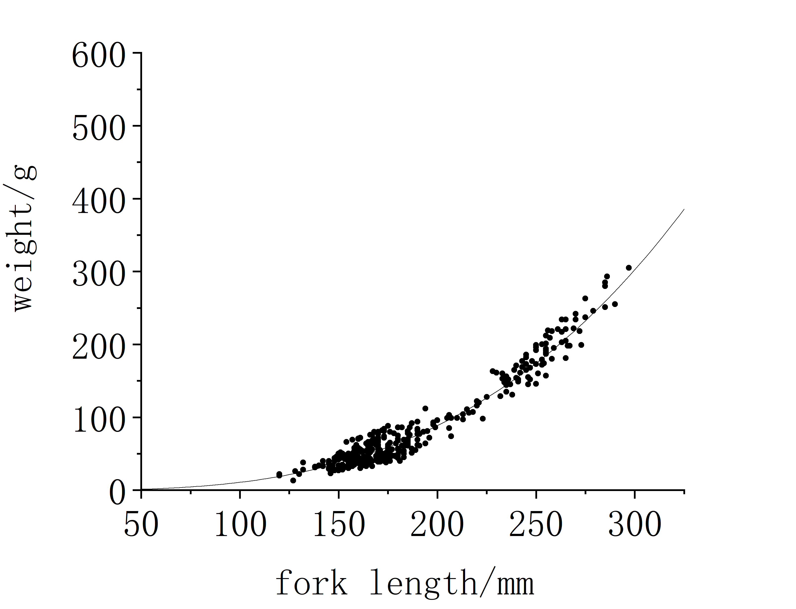 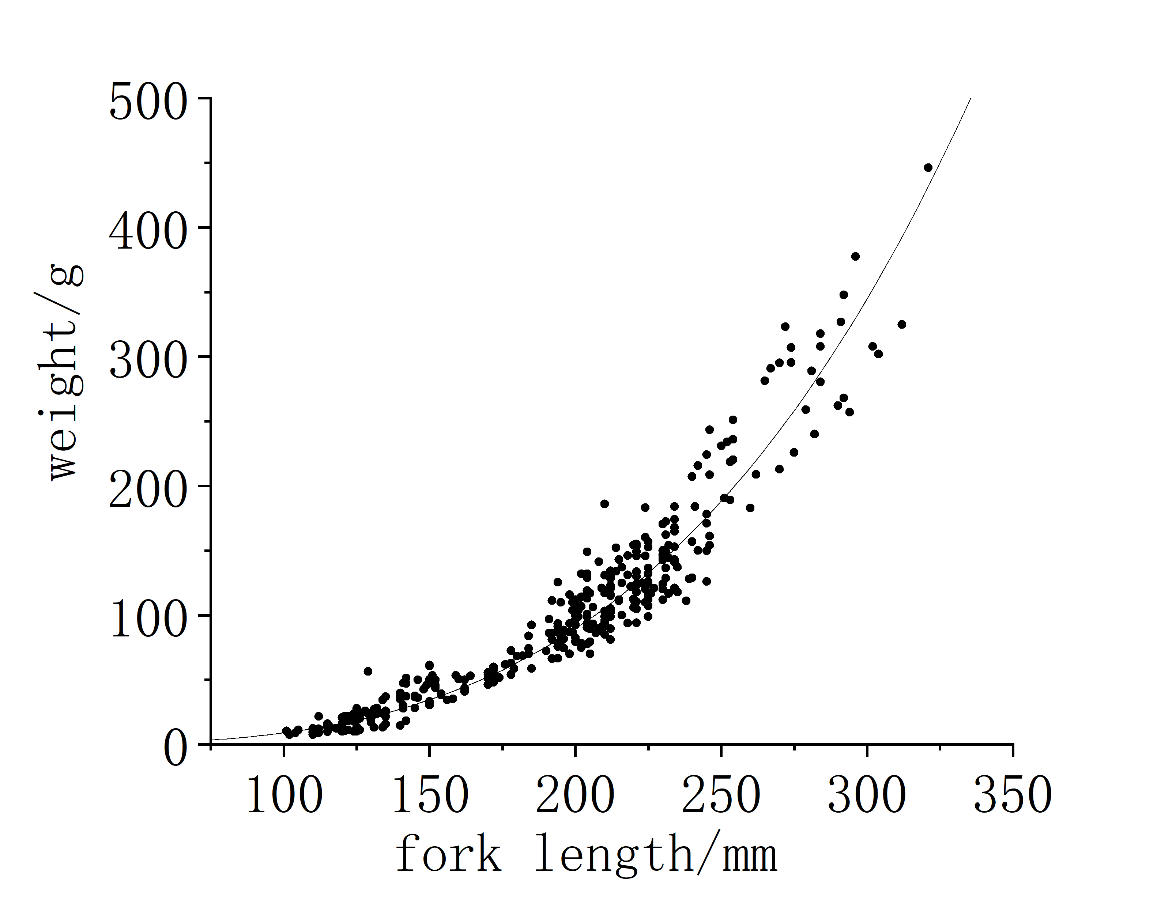

**Figure 3 The fork length-weight relationship of Chub mackerel from 2021 to 2023 (left, middle, right, respectively)**

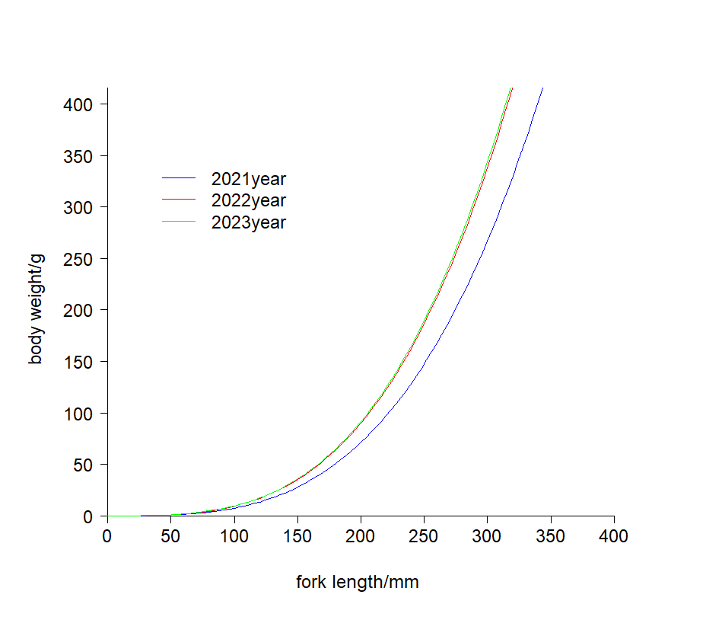

**Figure 4 The temporal heterogeneity of length weight relationship of Chub mackerel in 2021-2023.**

The growth parameters in the von Bertalanffy growth function were also estimated for Chub mackerel, *K=*0.33~0.78, $L_{∞}$ =31~34 cm, and *t*0= -0.34 ~ -0.82 (Table 3). Values of these parameters in other years were derived from references, including *t*max=11, which were required to estimate natural mortality for Chub mackerel.

Both constant and age-specific natural mortality were calculated. Constant *M* results varied much from different method, ranged from 0.08 to 1.67 (Table 4). The age specific *M* values decline from 0.70 at age 1 to 0.38 at age 4 from Gislason1 method and from 0.72 to 0.41 from Charnov method (Table 5).

Large variations were indicated to the *M* estimates from different methods based on growth parameters from various references. There are some exteme values due to highly dependence to single parameter or large uncertainty on growth parameters. For example, M4 (Zhan) and M7 (Hoening) only relies on the maximum age *t*max. The growth parameter, *k*, estimated from Cai *etal* 2022, is extremely low for Chub mackerel. Therefore, the geometrical mean were calculated for natural mortality in each year, ranging from 0.26 to 0.62, with 0.47 for values in all years.

**Table 3 Growth parameters of Chub mackerel in the Northwest Pacific from different resources in the years 2016 to 2023**

|  |  |  |  |  |  |  |
| --- | --- | --- | --- | --- | --- | --- |
| **Data source** | **Year** | ***t*0** | ***L*∞（cm）** | ***k*** | **（cm）** | $\overline{T}$**（℃）** |
| Zhao 2023 | 2016-2021 | -0.46 | 41.35 | 0.54 | 23.74 | 15.62 |
| Zhang *etal*. 2022 | 2018-2019 | -0.96 | 44.76 | 0.26 | 27.08 | 17.32 |
| Cai *etal*. 2022 | 2020 | -2.87 | 46.05 | 0.09 | 18.19 | 13.10 |
| This study | 2021 | -0.82 | 33.08 | 0.33 | 14.92 | 18.54 |
| This study | 2022 | -0.34 | 30.98 | 0.78 | 18.87 | 17.89 |
| This study | 2023 | -0.41 | 34.13 | 0.67 | 20.74 | 18.10 |

**Table 4 Natural mortality estimates for Chub mackerel based on growth parameters from different sources used 8 methods**

|  |  |  |  |  |  |  |
| --- | --- | --- | --- | --- | --- | --- |
| Source | Zhao 2023 | Zhang *etal*. 2022 | Cai *etal*. 2022 | This study | This study | This study |
| Year | 2016-2021 | 2018-2019 | 2020 | 2021 | 2022 | 2023 |
| M1 | 0.84 | 0.53 | 0.23 | 0.69 | 1.17 | 1.09 |
| M2 | 0.50 | 0.24 | 0.08 | 0.32 | 0.75 | 0.64 |
| M3 | 1.24 | 0.55 | 0.36 | 1.09 | 1.64 | 1.41 |
| M4 | 0.23 | 0.23 | 0.23 | 0.23 | 0.23 | 0.23 |
| M5 | 0.81 | 0.39 | 0.14 | 0.50 | 1.17 | 1.00 |
| M6 | 0.19 | 0.40 | 0.59 | 0.33 | 0.09 | 0.13 |
| M7 | 0.40 | 0.40 | 0.40 | 0.40 | 0.40 | 0.40 |
| M8 | 1.21 | 0.53 | 0.36 | 1.13 | 1.67 | 1.35 |
| Range | **0.19-1.24** | **0.23-0.55** | **0.08-0.59** | **0.23-1.13** | **0.09-1.67** | **0.14-1.35** |
| Geomean | **0.55** | **0.39** | **0.26** | **0.50** | **0.62** | **0.60** |

**Table 5 Age specific natural mortality using “Gislason1” and “Charnov” estimators with the growth parameters values (Lꝏ=44.76, K=0.26 and mean length in each age) estimated from Heng Zhang et al 2023.**

|  |  |  |  |
| --- | --- | --- | --- |
| Age | Length | Gislason1 | Charnov |
| 0 | 17.73 | - | - |
| 1 | 22.69 | 0.70 | 0.72 |
| 2 | 27.44 | 0.52 | 0.54 |
| 3 | 32.33 | 0.40 | 0.42 |
| 4 | 33.02 | 0.38 | 0.41 |

**Discussion**

This study provided the estimates of growth parameters and natural mortality for Chub mackerel in the convention area from Chinese fishery and survey. Different dataset among regions and years yielded varied results, while Chub mackerel tends to grow faster with smaller size in recent years and high sea.

Generally, the results suggests obvious variations among different regions and years, indicating the non-stationarity of Chub mackerel’s life history traits. Temporal variation in recruitment and other life-history rates, spatial structure and movement, and species interactions are key considerations for small pelagic fishes. We strongly recommend the stock assessment for Chub mackerel using time-varying growth and mortality considering spatial heterogeneity.

**Acknowledgement**

This document is supported by the National Natural Science Foundation of China (32202934), and the Program on the Survey, Monitoring and Assessment of Global Fishery Resources (Comprehensive scientific survey of fisheries resources at the high seas) sponsored by the Ministry of Agriculture and Rural Affairs.

**Reference**

Alverson D L, Carney M J. A graphic review of the growth and decay of population cohorts[J]. ICES Journal of Marine Science, 1975, 36 (2): 133-143.

Cai K, Kindong R, Ma Q, et al. Growth Heterogeneity of Chub Mackerel (*Scomber japonicus*) in the Northwest Pacific Ocean [J]. Journal of Marine Science and Engineering, 2022, 10(2): 301.

Charnov E L, Gislason H, Pope J G. Evolutionary assembly rules for fish life histories[J]. Fish and Fisheries, 2013, 14.

Charnov E L, Gislason H, Pope J G. Evolutionary assembly rules for fish life histories[J]. Fish and Fisheries, 2013, 14.

Gislason H, Daan N, Rice J C, et al. Size, growth, temperature and the natural mortality of marine fish[J]. Fish and Fisheries, 2010a, 11: 149-158.

Hoenig, J M. Empirical use of longevity data to estimate mortality rates[J]. U.S. National Marine Fisheries Service Fishery Bulletin, 1983, 81: 898-903.

Jensen A L. Beverton and Holt life history invariants result from optimal trade-off of reproduction and survival[J]. Canadian Journal of Fisheries and Aquatic Sciences, 1996, 53(4):820-822.

Kamimura, Y., Taga, M., Yukami, R., etal. Intra-and inter-specific density dependence of body condition, growth, and habitat temperature in chub mackerel (*Scomber japonicus*). BioRxiv, 2021.03.25.436928.

Lizuka K. Chub mackerel stock and fishing ground in the1960s-1970s.Kaiyo Monthly，2022，34: 273-279

Norio Takahashi, Yasuhiro Kamimura, Momoko Ichinokawa, etal. A Range of Estimates of Natural Mortality Rate for Chub Mackerel in the North Pacific Ocean[R], 2019.

Pauly D. On the interrelationships between natural mortality, growth parameters, and mean environmental temperature in 175 fish stocks[J]. ICES Journal of Marine Science, 1980, 39(2): 175-192．

Pauly D. On the interrelationships between natural mortality, growth parameters, and mean environmental temperature in 175 fish stocks[J]. ICES Journal of Marine Science, 1980, 39(2): 175-192．

Shota Nishijima, Yasuhiro Kamimura, Ryuji Yukami, etal. Update on natural mortality estimators for chub mackerel in the Northwest Pacific Ocean [R], 2021. NPFC-2021-TWG CMSA04-WP05.

Siple, M. C., Koehn, L. E., Johnson, K. F., et al. Considerations for management strategy evaluation for small pelagic fishes. Fish and Fisheries 2021; 22: 1167–1186.

Takahashi, N., Kamimura, Y., Ichinokawa, M., etal. A range of estimates of natural mortality rate for chub mackerel in the North Pacific Ocean. 2019. NPFC-2019-TWG CMSA02-WP01.

Zhan Binyi, Lou Dongchun and Zhong Junsheng. An Assessment of The Filefish Population and Rational Exploitation of The Resource[J]. Journal of Fisheries of China,1986,10(4):408-418.

Zhang H, Delong Xiang, Yuyan Sun,Yang Li, Yongchuang Shi. Content of the document for data description on CM in China [R], 2023. NPFC-2023-TWG CMSA07-IP03.

Zhang, H., Yang, C., Xu, B., etal. Age and Growth of Japanese Mackerel in the High Seas of the Northwest Pacific Ocean. Open Journal of Animal Sciences , 2022, 12, 91-102.

Zhao G. Study on fishery biology and fishing ground changes of chub mackerel (*Scomber japonicus*) in the high seas of the Northwest Pacific [D]; Shanghai Ocean University, 2023.